 | OPTIMISATION  Investigation 3  Name

Take home part
Course-related information

The concepts and skills covered in this investigation relate to the following dot points within the WA Mathematics Methods syllabus:

2.3.14 identify and use linearity properties of the derivative
2.3.15 calculate derivatives of polynomials
2.3.21 solve optimisation problems arising in a variety of contexts involving
polynomials on finite interval domains
The ability to choose and use appropriate technology to enhance concept development is also required for this task.

Background information

Students will have used to determine area of a triangle as well as the cosine rule to determine unknown sides of a triangle in Unit 1. Students need to be able to differentiate polynomials - using the linearity properties would ease the process of differentiation. In particular:
If,

This task could be used as part of the learning of 2.3.21 and for the in-class validation students should be able to set the derivative to zero and solve the resulting equation.

Task conditions

The preparation activities could be done in class and students could bring a page of notes summarising their findings to the validation activity. Students should have access to technology for calculations and it is assumed that such technology will also provide the derivatives. Measurement formulae are provided in most instances.
Optimisation

Extended investigation Part 1: Preparation activity

Problem 1: Which solar panel has the greatest area?

The area of a glass solar panel needs to be at a maximum to “collect” the greatest amount of sunlight possible. The shape of the flat solar panel is allowed to vary but the metal strip around the edge of the panel (i.e., around the perimeter) is to be kept at a constant value of 8 m to minimise the cost of making the object. For the shapes provided, determine the area of the various panels and hence identify the shape with the maximum area.

A. Glass panel is square

The metal strip is 8 m. Determine the length of each side and hence the area of the square panel.

B. Glass panel is triangular in shape with all sides equal

The metal strip is 8 m. Determine the length of each side and hence calculate the area of the triangular panel using the formula

C. Hexagonal panel

The metal strip is 8 m and the panel is in the shape of a regular hexagon. Draw a labelled diagram to represent the panel identifying the length of the sides and the sizes of the equal angles. Use a dissection method and the formula to show that the area of the panel is where a is the length of each side.

D. Circular panel

The metal strip is 8 m. Determine the radius of the circular panel and hence the area of the panel.

Examining your results

Rank the four shapes provided in order of increasing area.

What feature of these shapes seems to be influencing this order of magnitude?

Suggest a possible range of values for the area of a regular pentagon with a perimeter of 8 m. Justify your choice of values. Calculate the area of the pentagon and relate your answer to the range of values that you predicted.

Problem 2: Which raised garden bed can contain the greatest volume of soil?

Raised garden beds come in a variety of shapes and sizes. Four three-dimensional shapes have been suggested for investigation. Assuming each of these shapes can be filled with soil, what is the maximum amount of soil each of the shapes can contain? The dimensions referenced refer to the inner measurements and the thickness of the garden bed can be assumed to be negligible.

For each of the shapes provided
- There is a given restriction on the relationship between some dimensions.
- Identify the formula for the volume of the shape.
- Use Calculus techniques to determine the dimensions that maximise the volume.
- Use the following directions to identify the maximum volume.

A. Garden bed is the shape of a rectangular prism

(a) The formula for the volume of a rectangular prism is .

(b) Given metres and the height (h) is half of the width, state the formula for Volume in terms of h only.

(c) Determine , the derivative of the expression for Volume.

(d) Let = 0 and solve for h.
[Note: Volume has a maximum value when the derivative is zero]

(e) Determine the other dimensions of the garden bed. Note that metres and the height (h) is half of the width.

(f) Substitute these values for h, l and w back into the formula for Volume as determined in part (b) and hence determine the maximum volume of soil that can be contained in this garden bed in the shape of a rectangular prism.

B. Garden bed has the shape pictured below
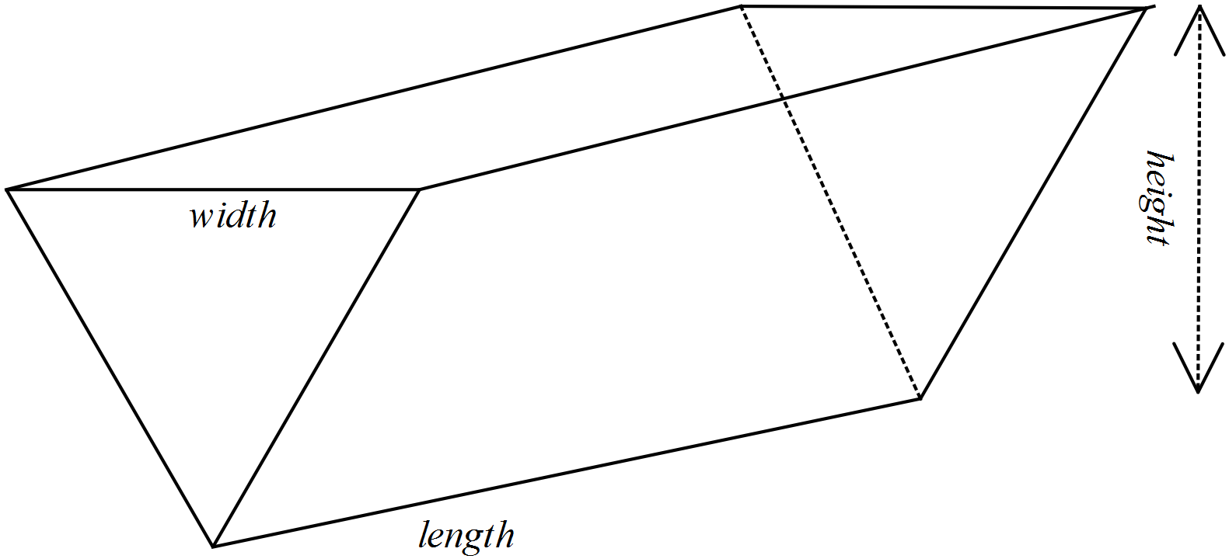

(a) The formula for the volume of this triangular prism is .

(b) Given the length plus width is 5 metres () and the height (h) is a quarter of the width, state the formula for Volume in terms of w only.

(c) Determine , the derivative of the expression for Volume.

(d) Let = 0 and solve for w.
[Note: Volume has a maximum value when the derivative is zero]

(e) Determine the other dimensions of the garden bed. Note that metres and the height (h) is a quarter of the width

(f) Substitute these values for h, l and w back into the formula for Volume as determined in part (b) and hence determine the maximum volume of soil that can be contained in this garden bed in the shape of a triangular prism.

C. Cylindrical garden bed

(a) The relationship between the height and the radius of a cylindrical garden bed is metres. Show that the rule for calculating the volume of the garden bed is .

(b) Use Calculus techniques to show that the volume is a maximum when the radius is metres.

(c) Determine the height of the garden bed when the volume is maximised.

(d) Determine the maximum volume of this cylindrical garden bed.

D. Garden bed in the shape of a hexagonal prism

The surface of the garden bed is in the shape of a regular hexagon. The volume of the prism is given by .

(a) Use the formula for area from Problem 1 plus the restriction that metres, where a is the length of each side of the hexagon, to generate a formula for volume in terms of a only.

(b) Use Calculus techniques to show that a maximum volume of 12.028 m³ occurs when metres.

(c) Calculate the height of the garden bed when the volume is maximised.

Examining your results

Enter your results in a table as follows:

Shape | Restriction | Dimensions for maximum volume | Maximum volume
Rectangular prism
Triangular prism
Cylinder
Hexagonal prism

Comment on your results, considering the following questions.

1. Can you conclude that a particular shape will give a maximum volume? Explain your decision.

2. Are any of the measures i.e., volume or dimensions the same for two or more shapes?

3. Would you expect the length to equal the height in the rectangular prism given this situation? Explain your decision.

4. What other methods, i.e., other than Calculus techniques could be used to determine the maximum volume of these 3-dimensional shapes? What are the advantages of using calculus techniques?

 | OPTIMISATION  Investigation 3 Term 3  Name

Optimisation

Extended investigation Part 2: In-class validation (50 marks)

Part A

When travelling by air, some destinations specify luggage limitations in linear measurements rather than weight. This is defined as
linear measurement = width + height + length.
For one airline the maximum linear measurement is 158 cm for any one piece of luggage. All the shapes considered in Part A have the maximum linear measurement and are to be investigated for their maximum volume.

Question 1 (12 marks)

Luggage item is the shape of a rectangular prism

The length (l) of this item is twice the width (w) of the item.

(a) State the rule to calculate the volume (V) of the item. (1)

(b) Show how you can determine that for the height (h), (2)

(c) Write the rule to calculate the volume in terms of w only. (1)

(d) Determine (2)

(e) For what value of w is the volume a maximum? (Use calculus) (2)

(f) Determine the maximum volume. (2)

(g) When the volume is a maximum, (2)

(i) what is the length?

(ii) what is the height?

Question 2 (7 marks)

Luggage item is the shape of a triangular prism

The length (l) of this item is twice the width (w) of the item.

(a) Given , the rule to calculate the volume (V) of the item, determine . (2)

(b) Use the expression for , identified in part (a) to determine the value of w for which the volume is a maximum. (2)

(c) Calculate the maximum volume. (1)

(d) When the volume is a maximum, (2)

(i) what is the length?

(ii) what is the height? (Use the linearity condition from page 7)
Question 3 (9 marks)

Luggage item is the shape of a cylinder

(a) Show that the volume of the cylinder is given by the rule (3)

(b) Use calculus techniques to show that a maximum volume occurs when the radius (r) is cm (3)

(c) Determine (3)

(i) the maximum volume of the cylinder

(ii) the length of the cylinder when the volume is at a maximum.

Question 4 (11 marks)

Luggage item is the shape of a hexagonal prism; the base is a regular hexagon.

The width and length are equal and they are each double the length of the congruent sides of the hexagon.

(a) The rule for calculating the volume of this hexagonal
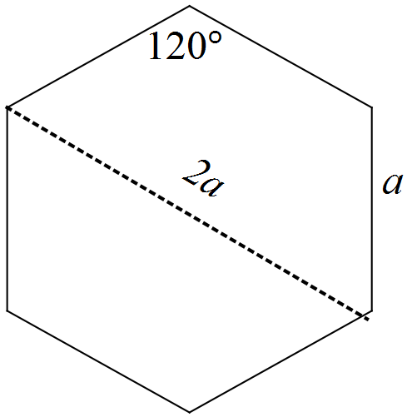 prism is .
Explain how this rule can be written as

(3)

(b) Use calculus techniques to determine the value of a for which this prism has a maximum volume. (4)

(c) Determine (4)
(i) the maximum volume

(ii) the dimensions of the prism for which the volume is maximised.

Part B

Question 1 (5 marks)

In Part A, differentiation has been used to identify the dimensions for which the volume of a 3-dimensional shape can be maximised.

(a) Describe how technology can be used to identify a maximum value for volume without differentiating the function. (2)

(b) What does the derivative of the volume function represent? (2)

(c) Why is the derivative of the volume function equal to zero when the volume reaches its maximum value? (1)

Question 2 (6 marks)

(a) Enter your results for the items of luggage in the table below. (1)

Shape | Maximum volume  (cm³) | Dimensions for maximum volume  (cm)
 |  | length | width | height
Rectangular prism
Triangular prism
Cylinder
Hexagonal prism

(b) Rank the items of luggage in order of increasing volume. Comment on your listing. (1)

(c) What aspects of the dimensions of luggage items appear to produce shapes with maximum volumes? (2)

(d) One passenger had an item of luggage that satisfied the rule for maximum linear dimensions but its volume exceeded all of those listed in the table. Suggest a possible shape and the dimensions for this item of luggage. Show that its volume is greater than those listed. (2)

Optimisation

Extended investigation Part 1: Preparation activity
Solutions

Problem 1

Solution

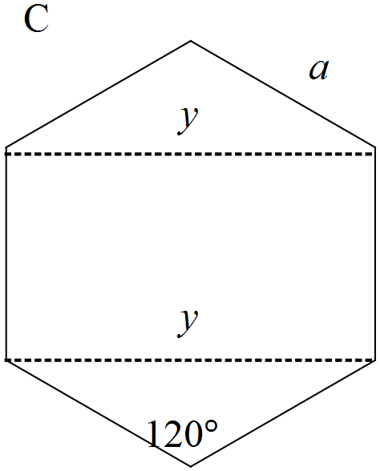A: Square
Length = 2 m, Area = 4 m²

B: Equilateral triangle
Length = m, Area =
C: Regular hexagon
Length of side = a = m
D: Circle
Radius =
Area =
In order of increasing magnitude the shapes are triangle, quadrilateral, hexagon, circle. The greater the number of sides the greater the area (assuming the circle has infinite number of sides)
A pentagon with a perimeter of 8 m would have an area between 4 and 4.619 m²

Pentagon
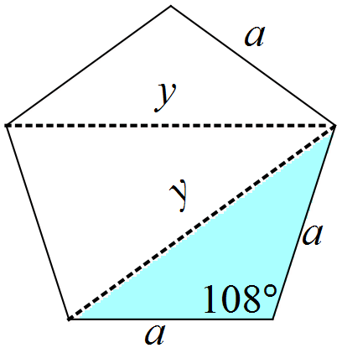a = 8 ÷ 5 = 1.6
For the two outer triangles
Area =
Using the cos rule
Non-congruent angle of middle triangle = 36º
Area of middle triangle =
Total area = 4.404 m² which is in the predicted range
Problem 2

Solution

A: Rectangular prism
(b)
(c)
(d) metres
(e) metres
(f) m³

B: Triangular prism
(b)
(c)
(d) metres
(e) metres
(f) m³

C: Cylindrical garden bed
(a)
(b)
(c)
(d) Maximum volume =
Problem 2 (cont’d)

D: Hexagonal prism
(a)

(b)

(c)

ALTERNATELY (and more accurately)
(a)

(b)

(c)

Problem 2 (cont’d)

Shape | Restriction | Dimensions for maximum volume (m) | Maximum volume  (m³)
Rectangular prism |  |  | 2.31
Triangular prism |  |  | 2.31
Cylinder |  |  | 14.544
Hexagonal prism |  |  | 12.028

Comment

- There is no clear indication from these results that a particular shape will produce the maximum volume as two shapes have the same volume. There is not a consistent restriction (variables not controlled) for a conclusion to be valid.
- The restrictions appear similar – comparing the cylinder and the hexagonal prism but in one case it was half the width + 4 h = 5 and in the other case it was the length of the sides + 4h = 5. These are not comparable as they measure different aspects of the shape.
- The similarity in the restrictions led to similar formulae for volume and hence similar dimensions for maximum volume for the cylinder and the hexagonal prism; however, the volumes do not appear to be related.
- The area of a rectangle of fixed perimeter is maximised when the rectangle is also a square and this principle could explain the congruent length and width in the maximised volume for the rectangular prism.
- Another method to locate a maximum value for volume is to plot the volume function (when reduced to one variable) and find the local maximum on the graph. Calculus offers a more accurate and quicker way to locate the maximum value.

Optimisation

Extended investigation Part 2: In-class validation
Solutions and marking key

Question 1

 | Solution | Marking key/mathematical behaviours | Marks
(a) |  | - Identifies formula for volume | 1
(b) |  | - Identifies expression with 3 dimensions  - Substitutes another expression for length | 1  1
(c) |  | - Identifies expression for volume | 1
(d) |  | - Differentiates expression for volume  - Applies linearity | 1  1
(e) |  | - Equates derivative to zero  - Solves resulting equation discarding zero result | 1  1
(f) |  | - Substitutes w into expression for volume  - Calculates volume and states units | 1  1
(g) | Length is 70.22 cm  Height = 52.67 cm | - Determines length  - Determines height | 1  1

Question 2

 | Solution | Marking key/mathematical behaviours | Marks
(a) |  | - Differentiates expression for volume  - Applies linearity | 1  1
(b) |  | - Equates derivative to zero  - Solves resulting equation discarding zero result | 1  1
(c) |  | - Calculates volume | 1
(d) | Length is 70.22 cm  Height = 52.67 cm | - Determines length  - Determines height | 1  1

Question 3

 | Solution | Marking key/mathematical behaviours | Marks
(a) |  | - Expresses relationship between radius or diameter and height  - Determines h in terms of r  - Substitutes expression for h in formula for volume of a cylinder | 1  1  1
(b) |  | - Differentiates expression for volume  - Applies linearity  - Equates derivative to zero and determines value for radius | 1  1  1
(c) | (i)  (ii)  Length = 158 – 2d = 52.67 cm | - Substitutes value for r into formula for volume  - Calculates volume  - Determines length | 1  1  1

Question 4

 | Solution | Marking key/mathematical behaviours | Marks
(a) |  | - Expresses relationship between w, l and a  - Express h in terms of a  - Substitutes expression for h in rule for volume | 1  1  1
(b) |  | - Differentiates expression for volume  - Applies linearity  - Equates derivative to zero  - Determines value for radius | 1  1  1  1
Question 4 (cont’d)

 | Solution | Marking key/mathematical behaviours | Marks
(c) | (i)  (ii)  Length = width = 2a = 52.67 cm  Height = 158 – length – width  Height = 52.67 cm | - Substitutes value for r into formula for volume  - Calculates volume  - Determines length, width and height | 1  1  2

Part B
Question 1

 | Solution | Marking key/mathematical behaviours | Marks
(a) | Graph the function for volume  Locate greatest value maximum value of “y” value | - Identifies alternate method  - Describes method | 1  1
(b) | Rate at which the volume changes with respect to one of the dimensions | - Describes changing rate  - Identifies variables | 1  1
(c) | The volume has stopped increasing | - Identifies zero rate of change | 1

Question 2(a)

Solution

Shape | Maximum volume  (cm³) | Dimensions for maximum volume  (cm)
 |  | length | width | height
Rectangular prism | 129 854 | 70.22 | 35.11 | 52.67
Triangular prism | 64 927 | 70.22 | 35.11 | 52.67
Cylinder | 114 735 | 52.67 | 52.67 | 52.67
Hexagonal prism | 94 885 | 52.67 | 52.67 | 52.67

Marking key/mathematical behaviours | Marks
- Completes table with data obtained | 1

Question 2

 | Solution | Marking key/mathematical behaviours | Marks
(b) | Triangular prism  Hexagonal prism  Cylinder  Rectangular prism  No pattern apparent in the listing – number of sides is increasing but for the rectangular prism | - Ranks and makes appropriate comment | 1
(c) | Height is always 52.67 cm  Height is one third of total linear measurement  Where there were no restrictions on length and width, they were equal and the shapes almost “cubic” | - Describes two aspects of the dimensions | 1  1
(d) | Rectangular prism with l = w = h = 52.67  Volume = 146 113 cm³ | - Identifies shape and dimensions satisfying condition  - Gives volume greater than those calculated | 1  1

